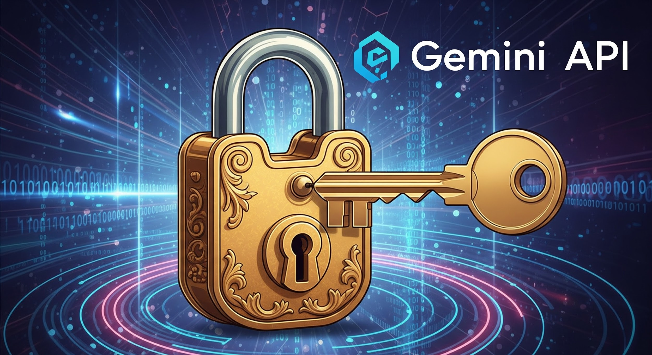

Gemini API Key Setup & n8n Integration

Jeavio Gen AI Session 3: **Design, Decide, Deliver: The Power of Structured LLM Workflows**

This guide provides a comprehensive, beginner-friendly walkthrough for obtaining a Gemini API key and integrating it with n8n for workflow automation. We will cover step-by-step instructions for getting your API key from Google AI Studio, signing up for n8n, and setting up n8n on the cloud.

# 1. Obtaining a Gemini API Key from Google AI Studio

Follow these steps to generate your Gemini API key from the Google AI Studio platform:

1. **Navigate to Google AI Studio**: Open your web browser and go to <https://aistudio.google.com/>.
2. **Log In**: If prompted, log in with your Google account.
3. **Access Get API Key**: On the top navigation panel, click on **"Get API key"** or locate the "API keys" section.
4. **Create API Key**: Click on the **"Create API key"** button.
5. **Copy Your API Key**: Once generated, your API key will be displayed. **Copy this key immediately and store it temporarily in a secure place (e.g., a text editor, but do not save it permanently in plain text).**
   * **WARNING**: Treat your API key like a password. Do not share it publicly or commit it directly into code repositories. If your API key is compromised, revoke it immediately from Google AI Studio.

# 2. Setting Up n8n for Workflow Automation

1. **Visit n8n Cloud**: Navigate to<https://n8n.io/> in your web browser.
2. **Click "Get Started"**: On the homepage, click the "Get Started" or "Sign Up" button.
3. **Choose Your Plan**:
   * Select the **Free tier** for getting started
   * Or choose a paid plan if you need more executions and features
4. **Create Account**:
   * Enter your email address
   * Create a strong password
   * Accept the terms of service
5. **Verify Email**: Check your email for a verification link and click it to activate your account.
6. **Complete Setup**: Follow the onboarding process to set up your first workspace.
7. **Access Dashboard**: Once verified, you'll be taken to your n8n cloud dashboard where you can start creating workflows.

# 3. Integrating Gemini API with n8n

Once you have n8n set up (cloud), you can integrate your Gemini API using the dedicated Google Gemini node:

## 3.1 Setting Up Google Gemini Credentials

1. **Create Gemini Credentials**:
   * In n8n, go to **Personal or Selected Project ( If Project is created )**→ **Credentials**
   * Click **"Add Credential"**
   * Search for **"Google Gemini (PaLM) API"**
   * Enter your Gemini API key that you obtained from Google AI Studio
   * Give it a name (e.g., "Google Gemini API Account")
   * Click **"Save"**

## 3.2 Creating Your First Gemini Workflow

1. **Create New Workflow**: In your n8n dashboard, click **"New Workflow"**
2. **Add Manual Trigger**:
   * Search for and add a **"Manual Trigger"** node
   * This allows you to execute the workflow manually for testing
3. **Add Google Gemini Node**:
   * Click the **"+"** button to add a new node
   * Search for **"Google Gemini"**
   * Select the **"Google Gemini"** node and select “**Message a model**” action
4. **Configure the Gemini Node**:
   * **Model Selection**: Choose **"models/gemini-2.0-flash"** from the dropdown
   * **Messages**: Enter your prompt (e.g., "Hello, Tell me about finetuning in one line")
   * **Credentials**: Select the Google Gemini credentials you created earlier
5. **Connect Nodes**: Connect the Manual Trigger to the Google Gemini node
6. **Test the Workflow**: Click **"Execute Workflow"** to test your setup

# 4. Troubleshooting

## 4.1 Common Issues

1. **API key not working**: Ensure your Gemini API key is valid and has proper permissions
2. **n8n connection issues**: Check your internet connection for cloud version
3. **Workflow execution failures**: Review error messages in the n8n execution log

## 4.2 Getting Help

* Visit [Google AI Studio Documentation](https://ai.google.dev/docs)
* Check [n8n Documentation](https://docs.n8n.io/)
* Access [n8n Community Forum](https://community.n8n.io/)
* Review [Google AI Studio](https://aistudio.google.com/) for API management
* Check [n8n docker setup configuration](https://docs.n8n.io/hosting/installation/docker/#prerequisites)